Computer Workshop 7: Linear models with a multiple predictors
Roos & Pinard
Last updated: 2024-08-23
Table of Contents

Workshop Structure
As always, we’re using our tried-and-tested workflow to guide today’s workshop:
- Formulate a research question.
- Perform exploratory data analysis (EDA).
- Identify any hidden assumptions.
- Fit an appropriate model [today’s main focus].
- Diagnose the model and check assumptions.
- Summarise the results.
- Interpret and draw conclusions.

A Slight Tweak to Our Workflow
Today, we’re going to explore two different approaches to modelling using the same dataset. You might recognize this dataset from the first week of the course — it contains information about flat prices in Aberdeen.
The two models we’re focusing on are:
- A predictive model aimed at predicting rent prices as accurately as possible.
- A causal model designed to understand the effect of square meters on rent price.
This exercise will show that the same statistical tools can be used for different goals — whether you want to build a simple predictive “AI” model or explore causal relationships.

Predictive Modelling
Predictive models are a great starting point because they’re usually more straightforward — no need to worry about tricky causal assumptions here (don’t tell the Machine Learning folks I said that!).

1. Formulate a Research Question
This one’s simple: We just want to predict rent price. We’re not interested in why a flat is more or less expensive; we just want to predict prices as accurately as possible.

2. Perform Exploratory Data Analysis (EDA)
As usual, spend a few minutes exploring the dataset. Check for any obvious errors or odd values. Since you have a link to each property, you can even verify unusual entries yourself; a rare luxury in science!

3. Identify Any Hidden Assumptions
Even in a predictive model, we need to think about potential hidden assumptions. If our data is flawed or not representative, our predictions will be flawed too. Take a moment to consider limitations. For example, can we use this model to predict rent prices in London?

4. Fit an Appropriate Model
One reason predictive modelling is so accessible is that we can throw all of our (sensible) explanatory variables into the model without worrying too much about the underlying relationships (obviously, we wouldn’t include the hyperlink as an explanatory variable in the model). But let’s keep it simple today. We’ll include the following predictors:
- sqmt: Property size in square meters.
- rooms: Total number of rooms (the sum of bedrooms and living rooms).
- epc: The property’s energy performance rating (categorical with levels A to G, A being the most energy efficient).
- tax: The council tax band based on the assumed property value in 1991 (categorical with levels A to G, G being the most expensive).
Notice that we’re using rooms in the model, but this variable isn’t in the dataset. You’ll need to create it by adding beds and living together (i.e., bedrooms and living rooms).
abdn$rooms <- abdn$beds + abdn$living
The statistical notation for this model is pretty miserable due to the many levels of epc and tax. Here’s what it looks like:
$price_{i}∼Normal\left(μ_{i},σ\right)$
$μ_{i}=β_{0}+β_{1}×sqmt_{i}+β_{2}×rooms_{i}+β_{3}×epcC_{i}+$ $β_{4}×epcD_{i}+β_{5}×epcE_{i}+β_{6}×epcF_{i}+β_{7}×epcG_{i}+$ $β_{8}×taxB_{i}+β_{9}×taxC_{i}+β_{10}×taxD_{i}+$ $β_{11}×taxE_{i}+β_{12}×taxF_{i}+β_{13}×taxG_{i}$
Where:
- $β_{0}$ is the intercept, representing a property with zero square meters, zero rooms, an EPC of B, and a tax band of A.
- $β_{1}$ is the slope for each additional square meter.
- $β_{2}$ is the slope for each additional room.
- $β_{3,...,7}$ are the effects of each EPC rating compared to B.
- $β_{8,...,13}$ are the effects of each tax band compared to A.
As you can see, discretizing continuous variables can make your model crazily more complex. If EPC and tax were continuous variables, we’d estimate just four parameters instead of 14. A general tip: avoid creating categorical variables out of continuous ones when possible — it’ll save you headaches down the road (and often makes your analyses more reliable).
Despite the complexity, running this model in R is straightforward:
rent_mod <- lm(price ~ sqmt + rooms + epc + tax, data = abdn)
Now let’s take a look at the estimated parameters using summary():
summary(rent_mod)
This produces a whole list of estimated parameters; reminding us why it’s best to avoid excessive categorization. Keep this in mind for your future work (including your Honour’s project), both for simplicity and for more meaningful analyses!

5. Diagnose the model and check assumptions.
In previous workshops, we’ve saved assumption checks for the Friday session, but by now, you should be feeling more confident and able to do this more quickly.
Let’s run a quick diagnostic check:
par(mfrow = c(2,2))
plot(rent_mod)
## Warning: not plotting observations with leverage one:
## 88
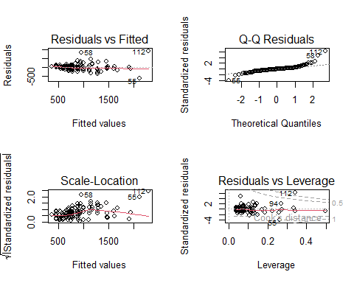
par(mfrow = c(1,1))

Question Set One
- Do you see any assumptions that are likely broken in the Residuals vs Fitted and Scale-Location plots?
# Yes, it looks like we have unequal variance of errors in both figures.
- If so, what is the consequence of violating this assumptions?
# Our confidence intervals will be artificially inflated, making our predictions look more uncertain than they should be.
- Do you see any assumptions that are likely broken in the Q-Q Residuals plot?
# Our residual errors are not perfectly Normally distributed, but they’re not that bad. We have three rental properties that are either more expensive or cheaper than we’d expect given the information provided to the model. If it were much more severe (e.g., dots all over the place), it could lead to inflated 95% confidence intervals.
- Are there any observations that are having a disproportionate affect on the model?
# Yes, a few. We can see these in the Residuals vs. Leverage plot, particularly the rental properties on rows 112 and 88 of our dataset (note that 88 doesn’t appear on the plot but is highlighted by the text output).
- If there are any such observations, what should we do about them (if in doubt, ask a member of staff)?
# We have three options, though one isn’t very practical for us today:
# 1. Collect more data: This is the ideal solution. Influential observations are usually more problematic in smaller datasets, so gathering more data could help smooth out their impact. Unfortunately, that’s not an option for us today.
# 2. Remove these observations and rerun the analysis: A lot of papers go with this approach. However, the problem comes when they don't make it clear that they've done this, or they remove the observations but don't show the what difference it made. This is not a good option. If you are going to remove the observations, then instead do option 3.
# 3. Rerun the model without these problematic observations and compare the parameter estimates of the two models. If removing them doesn’t drastically change the estimates, you might as well stick with the original model (telling your reader that you've checked both models and showing them both). If it does make a difference, things get more complicated. In that case, you should still report both models but focus on the one you feel is “better.” What “better” means here is up to you; there’s no definitively "right" answer (but not having high leverage might be a sensible measure).
# Here’s how you’d do option 3:
abdn_trimmed <- abdn[-c(112, 88),]
trimmed_rent_mod <- lm(price ~ sqmt + rooms + epc + tax, data = abdn_trimmed)
coef(trimmed_rent_mod) # coef() gives just the "coefficients" or parameter estimates
coef(rent_mod)
# By comparing the two models, you can see the effect these observations had. For example, removing them means that the effect of sqmt changes from about 10p per extra square meter to £2.34 per extra square meter.
Before moving ahead, remove any observations from your dataset and rerun your model. As a hint, if I believed the flats on rows 10 and 50 of the dataset were causing issues in the model, I could remove them by doing:
abdn <- abdn[-c(10, 50),]
The - before c() basically means “remove”, so here we’re removing rows 10 and 50 (remember that square brackets are organised as [row,column]).
Having removed these and rerun the model. Do a quick quick of the diagnostic plots to see if this has resolved the issue.
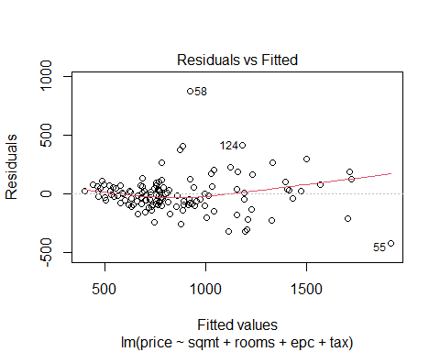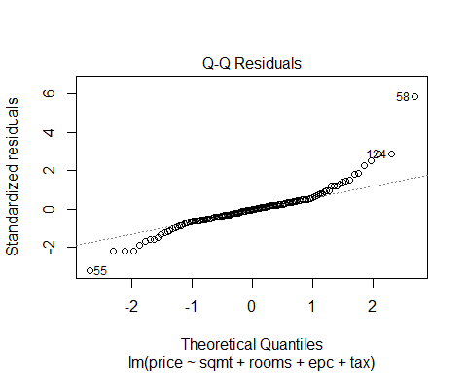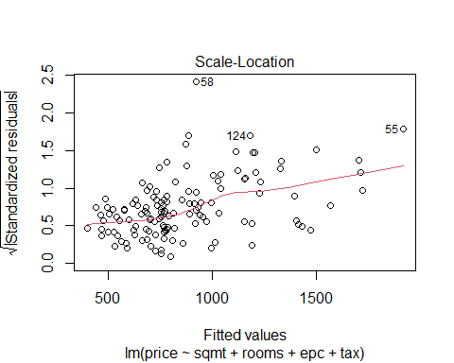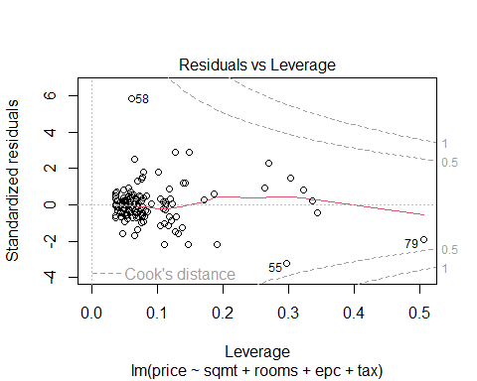

6. Summarise the results.
As usual, pull up the summary table:
summary(rent_mod)
Pay attention to the Estimate for sqmt; the model seems to be predicting that adding an extra 1 square meter to a property only increases the rent by about £2.34. Seems a bit low, right? Do we really think that the difference in price between a 50 m$​^{2}$ flat and a 100 m$​^{2}$ flat will be just £117 extra per month? We’ll come back to this after we run the causal version of this model.
Given the number of explanatory variables we have in our predictive model, we’ll use ggeffects to do the plotting, though you can definitely do this manually if you prefer more control (see the instructions with answers to see how to do that).
library(ggeffects)
Then ask ggeffects to predict rabbit weight for each of our mongoose categories:
preds <- ggpredict(rent_mod)
Now we just need to plot it:
plot(preds)
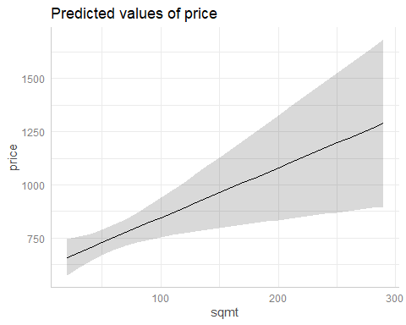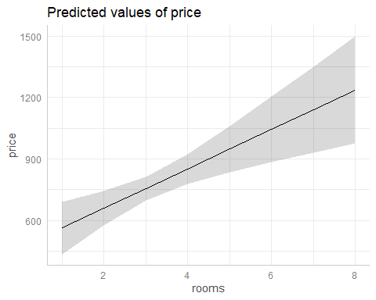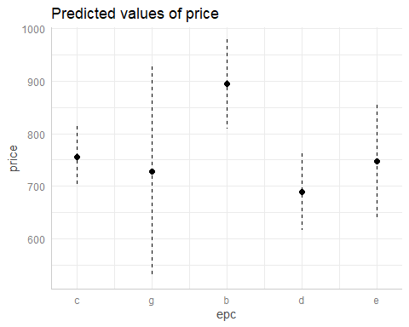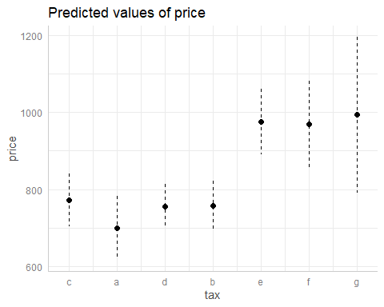
# To make these predictions manually we still do things the same way as before. The only extra complication is that we do this for each explanatory variable in turn. Additionally, we need to specify values for all explanatory variables, even those we aren't making predictions for:
fake <- data.frame(
sqmt = seq(from = min(abdn$sqmt), to = max(abdn$sqmt), by = 5),
rooms = median(abdn$rooms),
tax = "d",
epc = "d"
)
preds <- predict(rent_mod, newdata = fake, se.fit = TRUE)
fake$fit <- preds$fit
fake$low <- preds$fit - preds$se.fit * 1.96
fake$upp <- preds$fit + preds$se.fit * 1.96
# Plot
ggplot(fake) +
geom_ribbon(aes(x = sqmt, ymin = low, ymax = upp), fill = "lightgrey", alpha = 0.8) +
geom_line(aes(x = sqmt, y = fit)) +
labs(x = "Square meters",
y = "Predicted rental price") +
theme_minimal()

Question Set Five
- Can we identify any causal relationships from this model (e.g. “If you increase the square meters of a property by 10 meters squared, it will cause the rent to increase by X”)?
# No, we can't identify causal relationships with this model. This model is designed to predict rent prices and not to understand the cause-and-effect relationship between variables.
- Why might the relationship between price and sqmt be smaller than we’d expect?
# Probably because the size of the property *causes* the number of rooms you have. So if we provide the model with both explanatory variables sqmt and rooms, it only needs rooms to make an accurate prediction. Having both sqmt and rooms is redundant (for predictive modelling), because sqmt → rooms → price (or size causes rooms causes price). Basically, the model can "ignore" sqmt once we've told it about rooms.
- Go to the letting agency website, ASPC, and find a recently listed rental property which has all of the explanatory variables you need. Using your selected property, see how well your model predicts the rent. You’re also welcome to use your own flat if you know (or can guess) how many square meters it has, what the EPC rating is, and which tax band it falls in.
#E.g. I'll use this property: https://www.aspc.co.uk/search/property/427426/6-Joss-Court/Aberdeen/
# I need to create a dataframe to contain the relevant information:
joss_court <- data.frame(
rooms = 3,
sqmt = 61,
epc = "c",
tax = "c"
)
predict(rent_mod, newdata = joss_court)
# The model predicts this property should be £785, and is actually listed at £800 - £25 off is not bad for predicting the rent of a flat the model has never seen before! (That £25 is also the residual error!)
# We could always include 95% CI to see if the true rent is within our intervals (using a shortcut to getting 95% CI):
predict(rent_mod, newdata = joss_court, interval = "confidence")
# And the true rent is comfortably within our intervals
If you want to see how this kind of model could be translated into something you might see online with some marketing saying something like “We’re using the most advanced Generative Artificial Intelligence to predict how much rent you should be asking for”, see here. This is a little toy website I made (entirely in R). There are two important things to note; 1) I think there’s a decent chance the website will crash if lots of people try to use it at the same time, and 2) I include another model that deals with space - i.e. certain areas in Aberdeen are more expensive than others. One assumption we’re likely to break here is the assumption of independent errors, and including space in the model helps to account for that (this is the “Fancy model” on the site).

Causal Modelling
We’re now going to switch over to causal modelling using the same dataset. Hopefully the differences and similarities between the two approaches will become clear.
To be responsible, be sure to re-load the data again, so that any changes we made to it for the predictive model are not carried into our new analysis.

1. Formulate a Research Question
Our research question is going to be to understand the causal effect of square meters on rent price, or “What is the causal effect of the size of a rental property, in square meters, on the listed rental price?”.
Because we’ve already done an EDA and thought about hidden assumptions, we can skip these steps but before we get to fitting the model, we have an extra step when we want a model to potentially understand causation.

Extra: Creating a DAG
Because our question is causal, we can’t just use the approach we did above and throw everything into the model and read off every parameter estimate as being causal (something called the “Type 2 Fallacy”). Instead, we need to think about confounding and how to responsibly deal with that in our model. One of the least technical ways of doing this (but not the only way) is to create a Directed Acylic Graph (or DAG). This can often be a pretty laborious process, especially if you create your DAG in PowerPoint, but thankfully there’s a much easier way to do this in R using the package we’ve used previously - performance.
However, a slight complication is that we’re using a “developer” version of performance that hasn’t yet been put onto CRAN (the central repository where R packages are kept), so we’ll need to install the package directly from the developers. To do so, we’ll need to do a minor tweak to our install.packages() code where we say where the version is available from. At the same time, we’ll need to download an extra package called see from the same developers, which works with performance on some things in the background.
To install the correct version of performance re-install it by running:
install.packages(c("performance", "see"), repos = "https://easystats.r-universe.dev")
In R, the function check_dag() from the performance and see packages helps us create and evaluate a DAG. Here’s how it works:
- Specify the Causal Relationships for the Response Variable:
- You need to outline what you believe the causal relationships are. For example, if you think rent is influenced by the number of rooms, square meters, tax band, and EPC, you would “translate” this to Rent ~ Rooms + Sqmt + Tax + EPC. Note that the variable names in the model don’t have to match those in your dataset; just avoid using spaces in variable names, e.g., use Aberdeen_Rent instead of Aberdeen Rent.
- Define the Relationships Between Variables:
- Having done that, we now just go through what might cause our explanatory variables, for example the number of rooms you can have in a flat is must surely be caused by how many square meters there are, so we include this as: Rooms ~ Sqmt, and so on for the other explanatory variables.
- Set Up the Response and Explanatory Variables:
- The final part we need to complete is to define what our response variable is (called “outcome” by performance) and what our explanatory variable is (called “exposure”). This defines our initial and simple model, which in this case would be: Rent ~ Sqmt.
Here’s what your code might look like (but note that your DAG might look different from mine, e.g. maybe you don’t agree with me that EPC is caused by the size of a property):
library(performance)
## Warning: package 'performance' was built under R version 4.3.3
library(see)
## Warning: package 'see' was built under R version 4.3.3
rent_dag <- check_dag(
Rent ~ Rooms + Sqmt + Tax + EPC,
Rooms ~ Sqmt,
EPC ~ Sqmt,
Tax ~ Sqmt,
exposure = "Sqmt",
outcome = "Rent"
)
Once we’re happy that we have a DAG that seems sensible, we can then plot it:
plot(rent_dag)
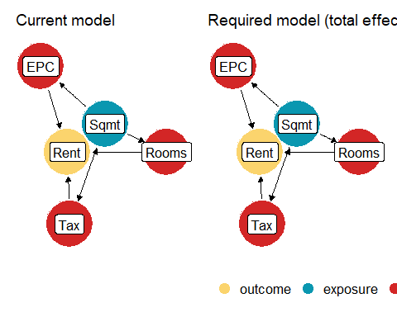
And we can use it to identify which model we should run to answer our research question:
rent_dag
This tells us that to estimate for the direct effect of Sqmt on Rent, we would also need to include EPC and Rooms, but we aren’t interested in just the direct effect, we want to understand what would happen to Rent if we increased a property by 10 square meters, so we want the total effects. For that, check_dag() has suggested that the initial model is correctly specified, where our initial model was Rent ~ Sqmt.

4. Fit an appropriate model.
Let’s run that model:
rent_causal_mod <- lm(price ~ sqmt, data = abdn)

5. Diagnose the model and check assumptions.
And we can do a quick check of the assumptions related to the model residuals:
par(mfrow = c(2,2))
plot(rent_causal_mod)
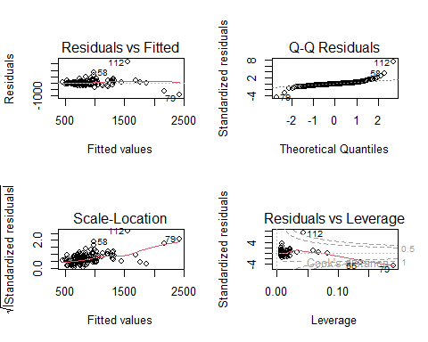
par(mfrow = c(1,1))
Most of the diagnostics look ok. Not great, but good enough to work with, with the exception of the Residuals vs Leverage plot.
Choose how to deal with the Residuals vs Leverage plot and rerun your analysis if necessary. For the remainder of this workshop instructions, I will remove any problematic observations and rerun the analysis (noting how much the results change).

6. Summarise the results.
The technical steps are exactly the same as for the predictive model. Get the model summary:
summary(rent_causal_mod)
And plot:
fake <- data.frame(
sqmt = seq(from = min(abdn$sqmt), to = max(abdn$sqmt), length.out = 10)
)
preds <- predict(rent_causal_mod, newdata = fake, se.fit = TRUE)
fake$fit <- preds$fit
fake$low <- preds$fit - preds$se.fit * 1.96
fake$upp <- preds$fit + preds$se.fit * 1.96
ggplot(fake) +
geom_ribbon(aes(x = sqmt, ymin = low, ymax = upp), fill = "lightgrey", alpha = 0.7) +
geom_line(aes(x = sqmt, y = fit)) +
labs(x = "Square meters of property",
y = "Predicted rent") +
theme_bw()
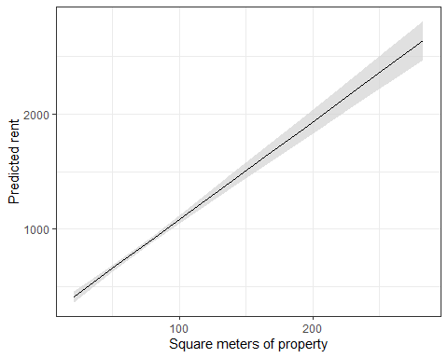
So what we learn is that for every additional meter square “added” the rent increases by roughly £8.50. So long as we assume that our DAG is accurate, this £8.50 increase is the causal effect of square meters on rent.
Compare that with our predictive model that found “adding” an extra square meter to a property would increase the price by £2.30. At the time, we noted that £2.30 seemed on the “cheap” side and the reason for the predictive modelling estimating it as being “cheap” was because, according to out DAG, m$​^{2}$ was confounded by the number of rooms in a flat. To be clear, that confounding didn’t matter for the first model because our aim was to make predictions, not to understand the causal effect.

What is the causal effect of EPC on price?
Repeat the above process, but where our research question is focused on understanding the causal effect of EPC on price.
Because we’re doing a new analysis, be sure to re-load the data before proceeding.
rent_dag <- check_dag(
Rent ~ Rooms + Sqmt + Tax + EPC,
Rooms ~ Sqmt,
EPC ~ Sqmt,
Tax ~ Sqmt,
exposure = "EPC",
outcome = "Rent"
)
rent_dag
# To estimate the causal effect of EPC, we need to include sqmt in the model:
epc_mod <- lm(price ~ epc + sqmt, data = abdn)
# Check diagnostics:
plot(epc_mod) # No issues with this model
summary(epc_mod)
plot(ggpredict(epc_mod, terms = "epc"))
# The causal effects seem to be all over the place. This either suggests that the DAG may be more complex than I've assumed, or we need more data to estimate this relationship properly.
# As an example, a more fleshed out version of the DAG would look like:
better_dag <- check_dag(
Rent ~ Rooms + Sqmt + Tax + EPC + PropertyType,
Rooms ~ Sqmt + PropertyAge,
EPC ~ Sqmt + PropertyAge,
Tax ~ HistoricPrice,
HistoricPrice ~ PropertyAge + PropertyType + Rooms + Sqmt,
Sqmt ~ PropertyAge + PropertyType,
exposure = "EPC",
outcome = "Rent"
)
# (But keep in mind, this doesn't include things like how nicely it's decorated, it's general maintainence, how greedy the landlord is, etc, etc)
plot(better_dag)
better_dag
# Which tells us that we'd one of the following models:
# Rent ~ EPC + PropertyType + Rooms + Sqmt + Tax
# Rent ~ EPC + HistoricPrice + PropertyType + Rooms + Sqmt
# Rent ~ EPC + PropertyAge + Sqmt
# The easiest of which would be the first, given PropertyType is the easiest variable to collect (property age is difficult, and historic price is probably impossible to get)
# The means that unless we get PropertyType, we can't currently understand the causal effect of EPC with the data as is
# This is a nice example of where doing the DAG *before* data collection helps to prevent headaches later on by identifying which variables to collect!

Assumption table
Assumption | Description | Example of Violation
1. Validity | The data is able to answer the research question effectively. | Using IQ to measure overall intelligence (what does IQ even measure?).
2. Representativeness | The data reflects the population or group being studied. | Using survey data from a rural area to draw conclusions about an urban population.
3. Additivity | Effects of predictors are additive and there are no interactions between them. | Assuming that study hours and sleep hours independently affect exam scores without considering their combined effect (imagine a Venn diagram with study and sleep overlapping).
4. Linearity | The relationship between predictors and the outcome is linear. | Assuming plant growth will continue to increase indefinitely without ever levelling out.
5. Independence of Errors | Observations are independent of each other. (Related to residual errors.) | If modelling height, the data come from the same group of children over time.
6. Equal Variance of Errors | Residuals have constant variance across all levels of predictors (“homoscedasticity”). (Related to residual errors.) | If modelling income, variability in salaries is not the same across all levels of a company’s hierarchy.
7. Normality of Errors | Residuals should be normally distributed. (Related to residual errors.) | If modelling income, the presence of any extremely wealthy individuals will be hard for the model to understand and explain.

